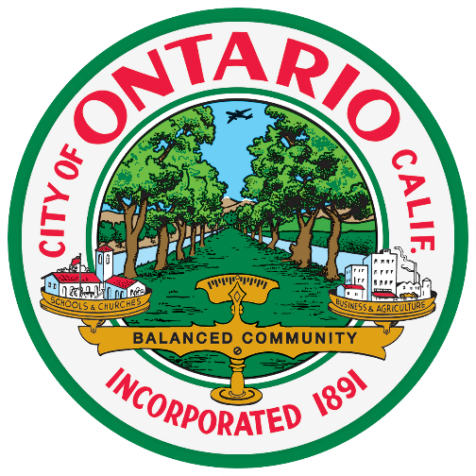

NOTICE OF CANCELLATION OF
REGULAR SCHEDULED
RECREATION AND PARKS
COMMISSION MEETING

The April 23, 2018 regular meeting of the Recreation and Parks Commission has been cancelled. Due to the observance of Memorial Day on May 28, 2018, the next regular meeting will be held on May 21, 2018 at 6:00 p.m. at the City Council Chambers.

Helen McAlary
Community Life and Culture Agency

