Circle either does or does not. Then paste a picture in the blank to make the sentence true.

The sun does/does not make a hot

The sun does/does not make a hot.

The sun does/does not make a hot.

The sun does/does not make a hot.
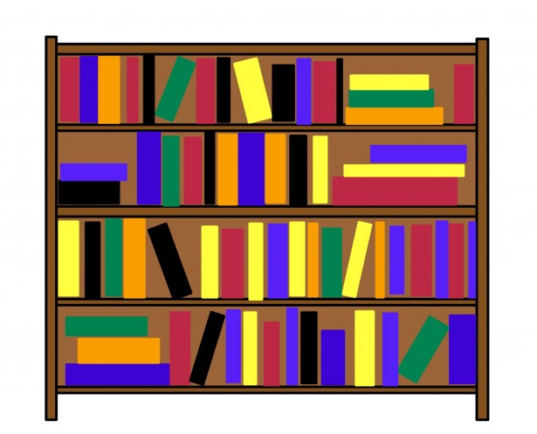
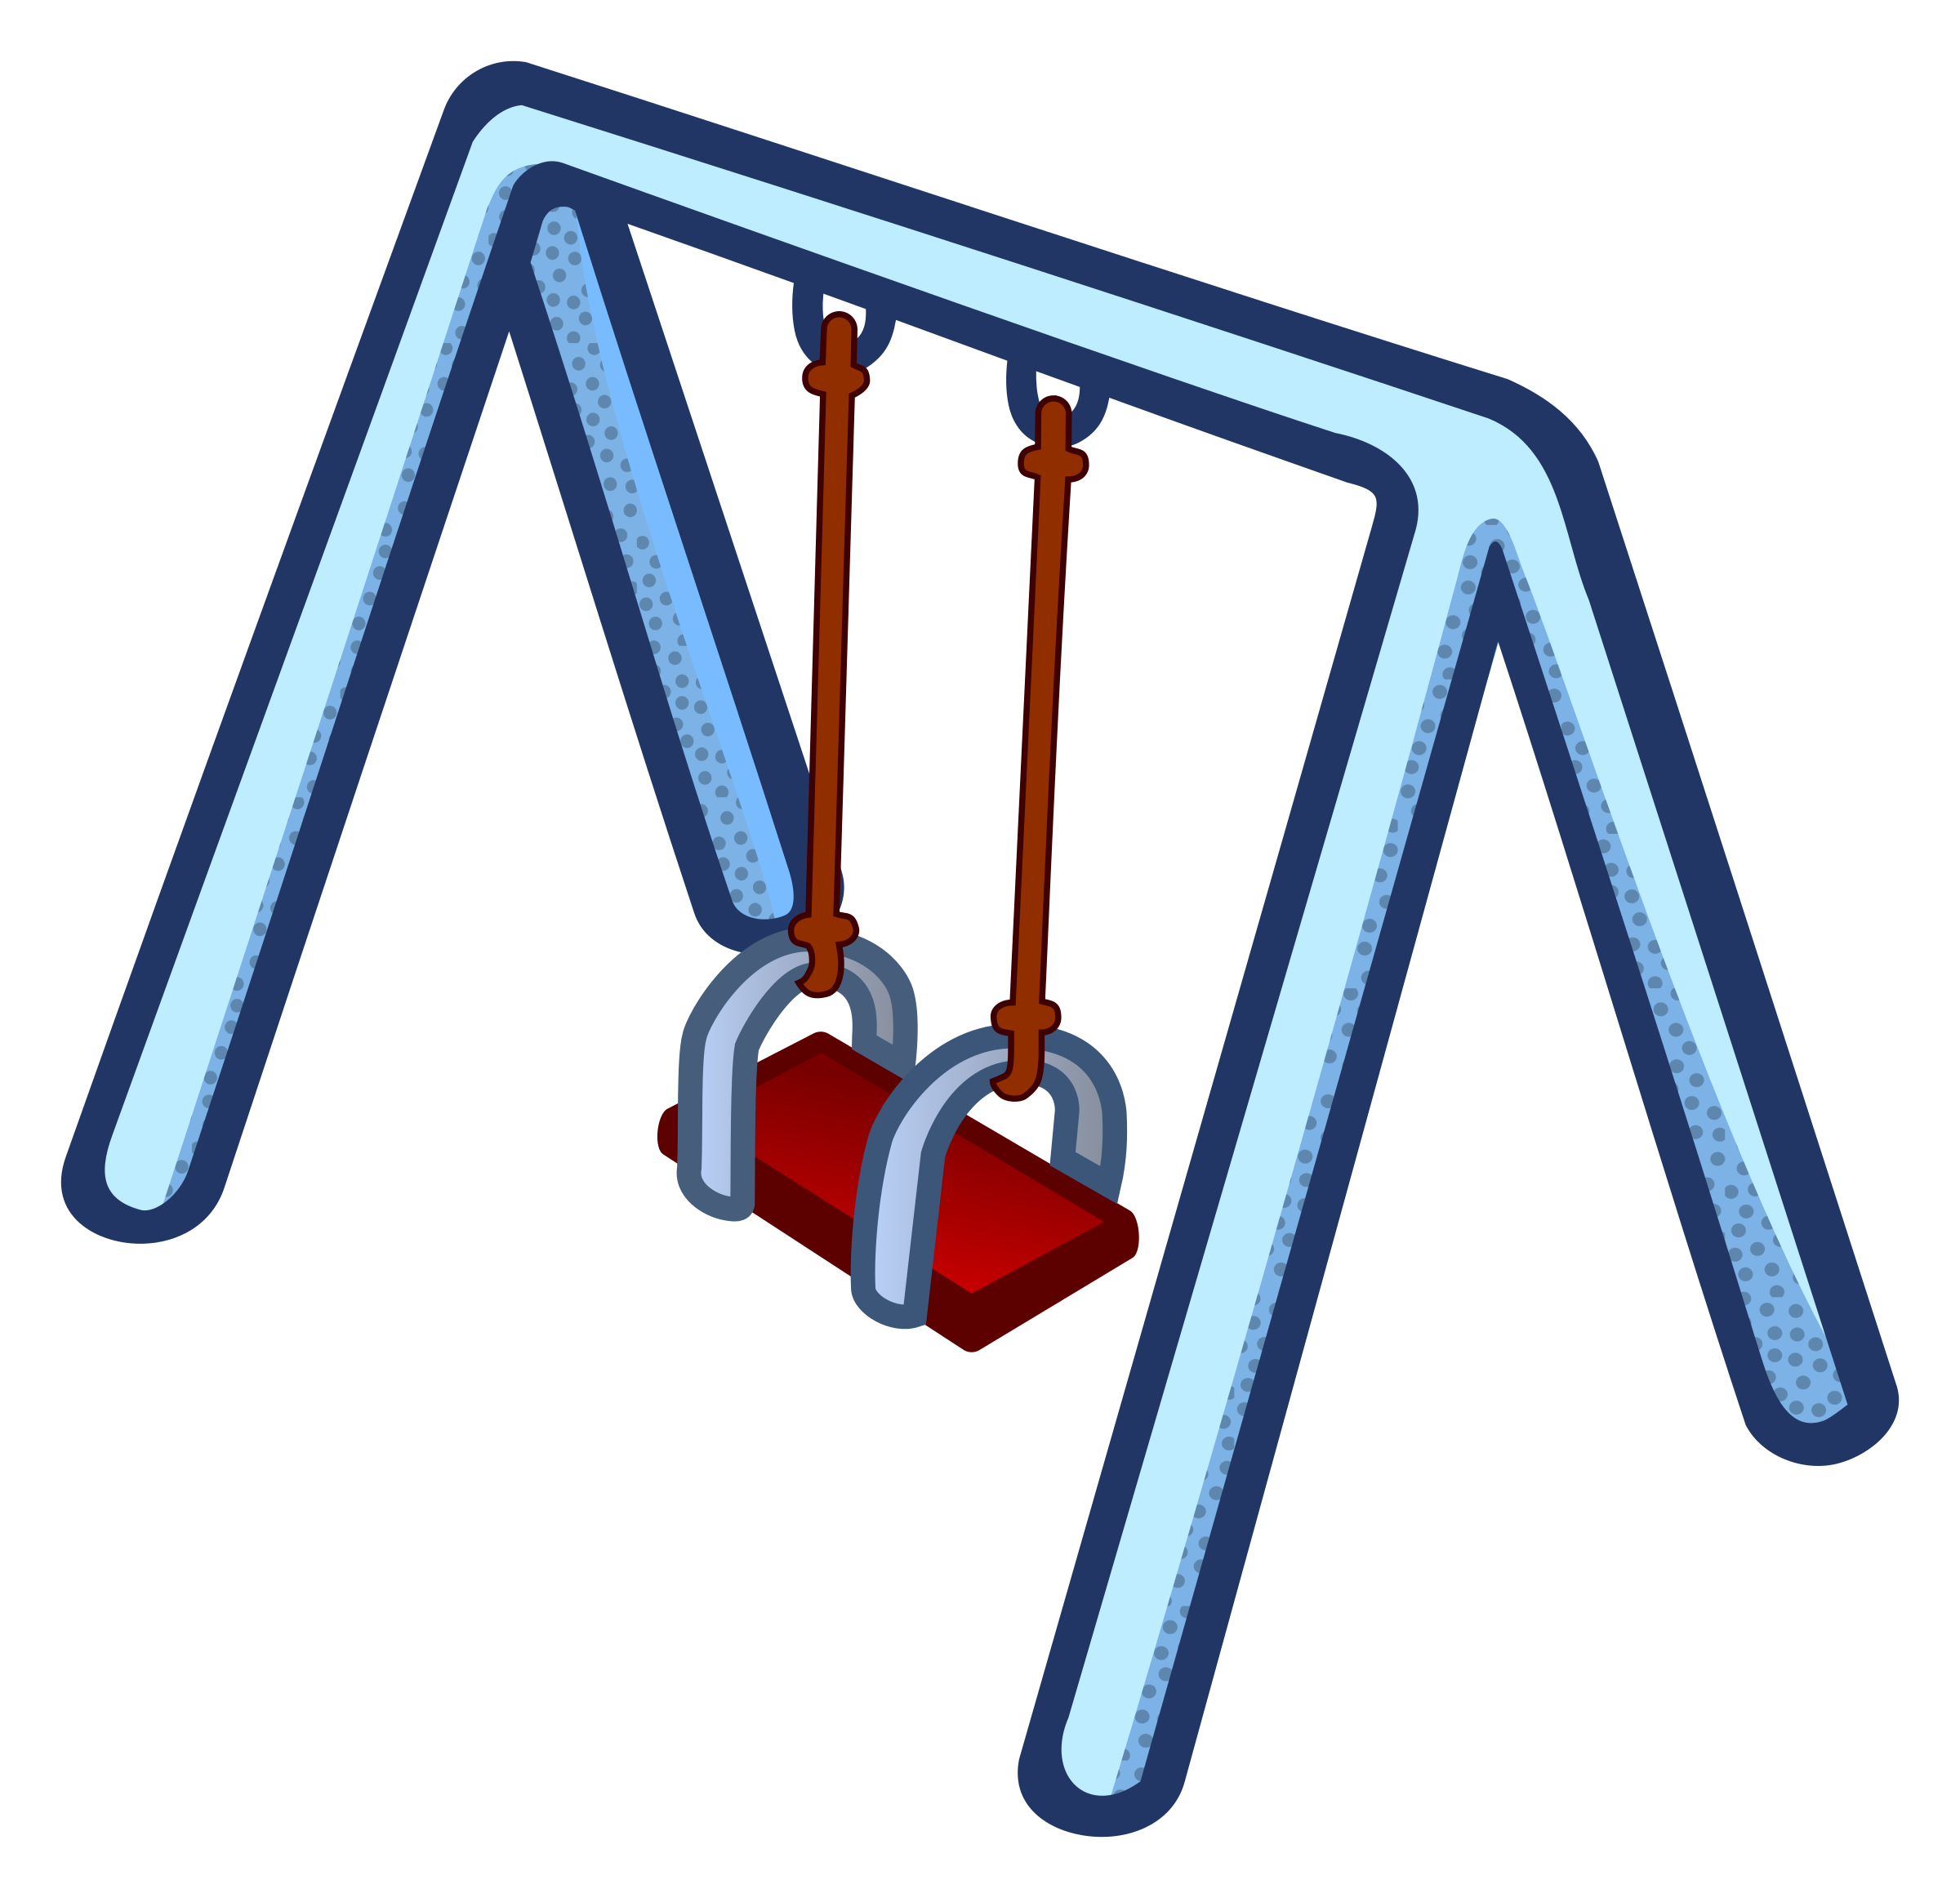
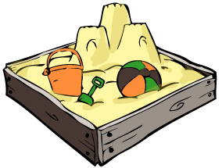
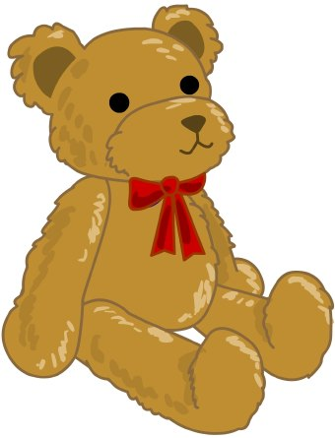
[Type a quote from the document or the summary of an interesting point. You can position the text box anywhere in the document. Use the Drawing Tools tab to change the formatting of the pull quote text box.]
[Type a quote from the document or the summary of an interesting point. You can position the text box anywhere in the document. Use the Drawing Tools tab to change the formatting of the pull quote text box.]
[Type a quote from the document or the summary of an interesting point. You can position the text box anywhere in the document. Use the Drawing Tools tab to change the formatting of the pull quote text box.]
[Type a quote from the document or the summary of an interesting point. You can position the text box anywhere in the document. Use the Drawing Tools tab to change the formatting of the pull quote text box.]
[Type a quote from the document or the summary of an interesting point. You can position the text box anywhere in the document. Use the Drawing Tools tab to change the formatting of the pull quote text box.]

