CFD Reimbursement Request Submittal Guidelines

General
- The total construction cost shall be consistent in all submitted documents, including Tab L, the Invoice Summary, the Summary of Cost, and the Summary of Checks and Invoice.
- The submittal should only include supporting documents related to the requested segments. The following are examples of documents that shall NOT be included in the submittal:
  - Applications for Business License, Development, etc.
  - Bid documents
  - Calculation worksheet
  - Change order, invoice, receipt, and progress billing that has no reference or is not related to the requested segment(s)
  - Check Request Form
  - Development Agreement
  - Duplicate items
  - Email
  - Engineering Cost Estimates
  - Fee schedule
  - Unsigned work order, contract, change order, payment request
- At a minimum, a pdf bookmark shall be created for EACH tab of the CFD Facilities Documentation Requirement Checklist, agreement, contract, and change order.
- The requested segment must be included in the CFD agreements. The description of the requested segment shall match the ones in the CFD agreements. If the requested segment is not included or if the segment description is not the same, an amendment to the agreement will be required.
Tab A – Cover Letter
- A cover letter shall be included with each submittal and shall include the following:
  - Total requested amount and the requested amount for each segment
  - An exhibit showing the locations of the infrastructure improvements included in the reimbursement request.
  - Response to any/all previous comments
- When the total construction cost or any cost item is distributed among different segments (e.g., ST-01, ST-13, ST-15) and/or different DIF categories (e.g., FO, ST, WT), the cover letter shall explain how the cost was distributed.
- If the contract and/or change order covers multiple segments, the cover letter shall explain how the corresponding contract value of the requested segment is determined. For example, a Professional Engineering Services Contract can include the design work for multiple sections, wich can be in different locations. The cover letter shall describe how the Total Contract Cost is split between the different segments.
Tab E – City Engineer Form
- The segment number, description, and location of the requested segments shall be included on the top of the Confirmation and Approval by the City Engineer Form and Attachment A of the form.
- The paragraphs that are not applicable to the requested segments on the City Engineer Form shall be removed or crossed out.
- If there are multiple segments included in the submittal, the individual segment costs and the total segment cost shall be included in Attachment A of the City Engineer Form.
Tab G – Purchase Price Payment Instructions form (Attachment B)
- Wire instructions may be included on a separate page following the Attachment B.
- The name and phone number of an authorized representative must be included on the separate page for wire instructions for confirmation of the bank account information. The Finance department will call to confirm the instructions prior to forwarding the directive to the Trustee.
Tab H – Summary of Expendable and Eligible Costs Form
- Each cost reported in Tab L shall match the amount shown in other documents, including Attachment A of the City Engineer Form, Change Order Summary, Checks and Invoices Summary, Summary of Costs, Payment and Reimbursement requests.
- A copy of ALL contracts, change orders, invoices, and unconditional waivers with vendors (contractors, engineers, consultants, etc.) listed on the form must be submitted.
- The CFD Segment No. and Description shall be based on the Requested Segment No. and the Segment Description in the Amended and Restated Acquisition and Funding Agreement of the requested segment.
- The Total CFD Segment Cost shall be based on the Acquisition Cost of the requested segment in the Acquisition and Funding Agreement for CFDs formed prior to November 2022.
- For CFDs formed after November 2022, the Total CFD Segment Cost shall be based on the approved Actual Costs to construct the segments.
- The Maximum Expended and Eligible Cost shall be the difference between the Total CFD Segment Cost and the Total NMC Builder Design Cost.
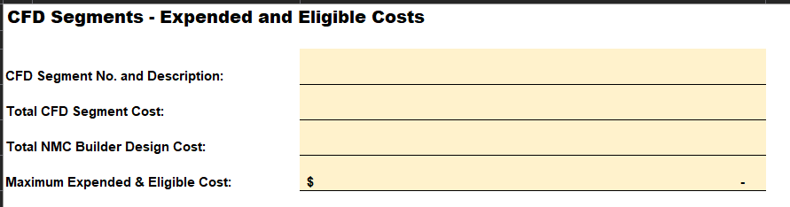
- The Total Expended and Eligible Costs shall be the sum of the Actual Cost Grand Total and the Design/Construction Management Cost and shall not exceed the Maximum Expended and Eligible Cost.
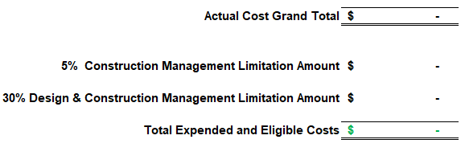
  - Construction Management Costs are limited to 5% of total soft costs.
  - Design and Construction Management Costs are limited to 15%-30% of total soft costs (based on Acquisition Agreement).
Tab K – Contracts and Change Orders
- All contracts and change orders must be signed.
- Backup documents are required to justify the eligibility of the change orders.
- A signed proposal is not a valid substitute for a signed contract.
Tab L – Invoices on the Expended and Eligible Costs Form
- All invoices must be signed by a valid party.
- A payment breakdown or summary is not a valid substitute for a signed progress invoice.
- In general, reimbursement can only be made up to the quantities shown on the Record Drawings. The extra quantities are not considered to be constructed because they were not recorded in the Record Drawings. Justification will need to be provided for special consideration.
- If Record Drawings were not provided in a CFD submittal. Tab L will not be reviewed because the quantities shown on the invoices and the total construction cost cannot be verified.
Tab M – Record Drawings
- Record Drawings must be stamped “Record Drawings”.
- Record Drawings for ALL requested segments must be provided.
- The locations shown on the Record Drawings must match the locations of the requested segments.
- Record Drawings are required and Approved Plans cannot be used to substitute for the Record Drawings.
Tab N – Notice of Completion (NOC)
- The improvements and locations described in the NOC shall match those of the requested segments.
- For example, if the requested segment is submitted for WT-011 Water Main in Archibald Avenue, the NOC shall show Archibald Avenue as the project location and the improvement work completed is for water main improvements.
Tab O – Unconditional Waiver Release Forms
- Canceled checks can be provided in lieu of unconditional waiver release forms for those work that received payment as part of the DIF reimbursement.
Tab P – Off-Site Improvements Acceptance Letter
- The improvements and locations described in the Acceptance Letter shall match those of the requested segments.
- For CFD submittals for Streets and Traffic Circulation System Facilities, a release email may be accepted in lieu of a signed Off-Site Improvements Acceptance Letter.
Tab Q – Warranty Bond
- The improvements/locations/Project No. described in the Warranty Bond shall match those of the requested segments.

