 | CITY OF ONTARIO  BUILDING DEPARTMENT  303 East B Street  Ontario, CA 91764  Ph (909)395-2023, Fax (909)395-2180 | INFORMATION BULLETIN  106  Effective: 1 / 1 / 2020 Revised: 9 / 12 / 2023
EGRESS WINDOW REQUIREMENTS FOR RESIDENTIAL

Egress windows (Emergency escape and rescue openings) requirements per 2022 California Residential Code:
- Every sleeping room, habitable attic, and basement shall have at least one operable egress window or door approved for emergency escape and rescue open directly into a public way, or to a yard or court that opens to a public way. Exceptions:
- Basement with a ceiling height of less than 80 inches.
- Basement or sleeping rooms that have an exit door or exit access door that opens directly into a public way or to a yard, court or exterior egress balcony that opens to a public way.
- Basements for mechanical equipment only and not larger than 200 square feet.
- Sleeping rooms in basements of fire sprinklered building not required to have egress windows provided that the basement has one mean of egress and one egress window OR the basement has two means of egress.
- Emergency escape and rescue openings shall be operational from the inside of the room without the use of keys, tools, or special knowledge.
- Egress window size shall comply ALL the following:
- The minimum net clear opening area shall be 5.7 square feet. Direct grade level egress windows can be 5.0 square feet minimum.
- The minimum net clear opening height shall be 24” and the minimum net clear opening width shall be 20”.
- Egress windows shall have the bottom of the clear opening not greater than 44” measured from the floor.
- Where security bars (burglar bars) are installed on egress windows or doors, such devices shall be releasable or removable from inside without the use of a key, tool, or special knowledge and must be approved by Fire Department.
- Retrofit windows must comply with the above requirements items 3 & 4 (Department Policy).

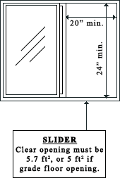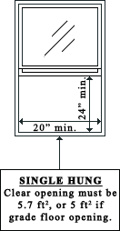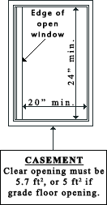

MINIMUM WIDTH AND HEIGHT FOR EGRESS WINDOWS AT GRADE FLOOR LEVEL (5.0 FT² MIN. OPENING AREA) :
Width (inches) | 20 | 20.5 | 21 | 21.5 | 22 | 22.5 | 23 | 23.5 | 24 | 24.5 | 25 | 25.5 | 26 | 26.5 | 27
Height (inches) | 36 | 35.1 | 34.3 | 33.5 | 32.7 | 32 | 31.3 | 30.6 | 30 | 29.4 | 28.8 | 28.2 | 27.7 | 27.2 | 26.7
Width (inches) | 27.5 | 28.0 | 28.5 | 29 | 29.5 | 30
Height (inches) | 26.2 | 25.7 | 25.3 | 24.8 | 24.4 | 24

MINIMUM WIDTH AND HEIGHT FOR EGRESS WINDOWS AT SECOND FLOOR OR HIGHER (5.7 FT² MIN. OPENING AREA) :
Width (inches) | 20 | 20.5 | 21 | 21.5 | 22 | 22.5 | 23 | 23.5 | 24 | 24.5 | 25 | 25.5 | 26 | 26.5 | 27
Height (inches) | 41 | 40 | 39.1 | 38.2 | 37.3 | 36.5 | 35.7 | 34.9 | 34.2 | 33.5 | 32.8 | 32.2 | 31.6 | 31 | 30.4
Width (inches) | 27.5 | 28 | 28.5 | 29 | 29.5 | 30 | 30.5 | 31 | 31.5 | 32 | 32.5 | 33 | 33.5 | 34 | 34.2
Height (inches) | 29.8 | 29.3 | 28.8 | 28.3 | 27.8 | 27.4 | 26.9 | 26.5 | 26.1 | 25.7 | 25.3 | 24.9 | 24.5 | 24.1 | 24

