 | CITY OF ONTARIO  BUILDING DEPARTMENT  303 East B Street  Ontario, CA 91764  Phone (909)395-2023, Fax (909)395-2180 | INFORMATION BULLETIN  110  Effective: 8 / 24 / 2006  Revised: 8 / 31 / 2023

METHANE ASSESSMENT FOR PROJECTS IN THE ONTARIO RANCH

(Formerly known as New Model Colony)

Applicants shall provide for the Building Department’s review and approval, a methane assessment report addressing whether the property in questions was ever used as a dairy, poultry ranch, hog ranch, livestock feed operation site, manure stockpile site, manure/livestock burial site, run-off ponds, or for any other purpose that might result in the deposition of materials which might produce methane.
The report shall be prepared by a licensed engineer or licensed geologist and shall include the following:
- Historic aerial photos and historic topographic map review.
- Interviewing the owner/land managers for possible locations of potential methane
generation areas.
- Site reconnaissance to determine the current site usage and conditions.
- Identifying potential methane areas.
- A proposed scope of work for post-grading methane investigation based on the historical
study.
This report may be included as part of the soils and geology report and shall be submitted to the Building Department for review and approval at the time building permit applications are filed.
All lots in potential methane areas identified in the Methane Site Assessment report shall be tested for the presence of any methane and its concentration 30 days after building pads are graded and created.
A report, prepared by a licensed engineer or geologist and separate from the Methane Site Assessment report, summarizing the methane test conducted, the location/lot where methane is found and its concentration, and the recommended mitigation measures shall be submitted to the Building Department for review and approval. This test report could be a standalone report or be a part of the soils and geology report. This test report should be submitted together with building plans when permit applications are filed, or thereafter as soon as it is available. No building permit will be issued until the test report is approved by the Building Department, and the lots with methane and any required mitigation measures are shown on building plans.

METHANE DESIGN GUIDELINES
Measured Methane Concentration (ppm) | Minimum Mitigation Guidelines
< 15,000 | Provide a 10-mil moisture barrier. Seal utility conduits and other penetration in an approved method.
> 15,000 | Provide a 10-mil moisture barrier. Seal utility conduits and other penetration in an approved method. Also include any remediation required by the Engineer of record.
Waste, Burial Site, Pond, Lowland | Require methane report prepared by a licensed engineer or geologist on required remediation.
ONTARIO RANCH BOUNDARY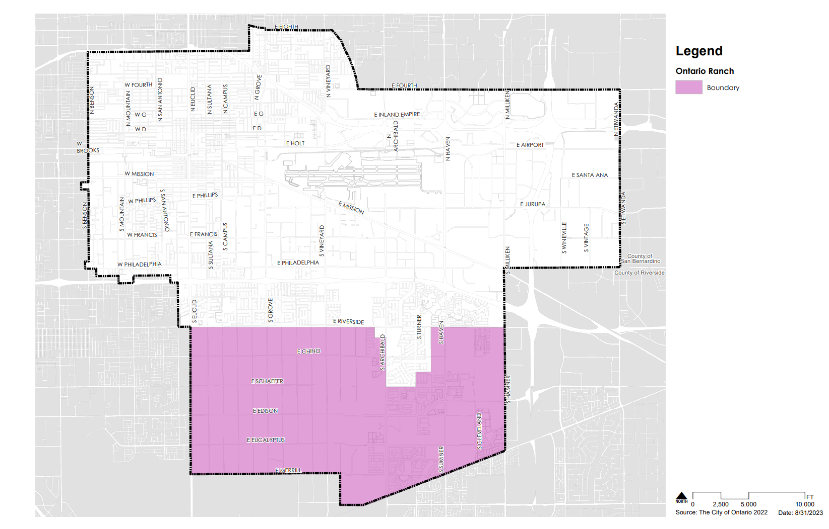

Approved by:  James Caro, BO | Date: | Prepared by:  Setiawan Ganda | Date:

