 | CITY OF ONTARIO  BUILDING DEPARTMENT  303 East B Street  Ontario, CA 91764  Phone (909)395-2023, Fax (909)395-2180 | INFORMATION BULLETIN  204  Effective: 9 / 14 / 2023 Revised: ----
6 FEET HIGH STEEL PICKET FENCE DETAILS

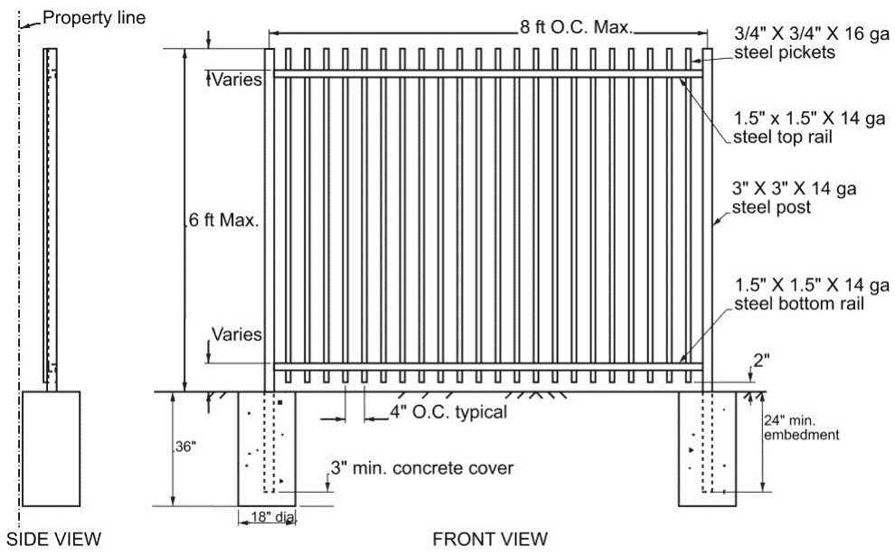

Approved by: (James Caro, BO) date:
Prepared by: (Setiawan Ganda) date:
 | CITY OF ONTARIO  BUILDING DEPARTMENT  303 East B Street  Ontario, CA 91764  Phone (909)395-2023, Fax (909)395-2180 | INFORMATION BULLETIN  204  Effective: 9 / 14 / 2023 Revised: ----
DESIGN CRITERIA:

- Applicable codes per 2022 CBC and ASCE 7-16.
- Wind speed 110 mph exposure C (per City Ordinance).
- Seismic Design Category D.
- Risk Category I or II.
- Allowable soil bearing pressure 1,500 psf, passive soil bearing 100 psf/ft.

MATERIAL SPECIFICATIONS:

- STEEL | ASTM A653/A653M [Standard Specification for Steel Sheet, Zinc-Coated (Galvanized) or Zinc-Iron Alloy Coated (Galvannealed) by Hot-Dip Process] with a minimum yield strength of 45,000 psi.
- WELD | AWS D1.1/D1.1M, “Structural Welding Code – Steel.”
- CONCRETE FOR FOOTING | 2,500 psi min. strength or optional mix of 1 part cement, 2½ parts sand, 3½ parts gravel of ¾” max. size, and 7 gallons of water per 90 lb sack of cement.

REQUIRED INSPECTIONS:

- Footing inspection (footings shall be excavated, free of soil and debris, with steel posts in place prior to placing the concrete)
- Final inspection (fence completed and site clean)

GENERAL NOTES:

- Shared Common Fences: if any portion of the fence footing encroaching property line, written permission from the adjacent property owner is required prior to permit issuance. Party Wall/Fence Letter form is available at City of Ontario Building Department web site.
- Finish grade shall be of equal elevation on each side of the fence.
- Steel picket fence over 3’-0” in height measured from adjacent grade shall require a building permit.
- Picket fence posts are not designed to support any vehicular gates. Separate vehicular gate support post is needed.
- Member sizes are minimum values.
- This detail does not cover electrical and zoning requirements.
- This detail is intended only for open fences. Solid backing or screen cover material attached to fence is not allowed.
- Fence used for pool/spa barrier must comply with California Residential Code:
  - Minimum 60” high fence.
  - Minimum 60” high access gates shall be equipped with a self-closing and a self-latching device placed no lower than 54” above floor on the pool side of gate. Access gates shall open outward away from the pool.
  - Maximum 2” vertical clearance from the ground to the bottom of fence.
  - Gaps or voids, if any, do not allow passage of a sphere equal to or greater than 4” in diameter.
  - An outside surface free of protrusions, cavities or other physical characteristics that would serve as handholds or footholds that could enable a child below the age of five years to climb over.

DISCLAIMER:
Alternate fence designs may be possible when provided with an engineered analysis. Use of this standard
design is at the user’s risk and carries no implied or inferred guarantee against failure or defects.

 | SITE ADDRESS: ___________________________________________  OWNER’S NAME: _______________________________________ | DATE:  _______________
INSTRUCTIONS:

- SHOW LOCATION OF STEEL PICKET FENCE RELATIVE TO THE PROPERTY LINE ON THE SITE PLAN BELOW.
- INDICATE THE LENGTH AND HEIGHT OF EACH FENCE.

SITE PLAN

PROPERTY LINE
PROPERTY LINE
PROPERTY LINE
HOUSE
DRIVEWAY
REAR YARD
FRONT YARD
PROPERTY LINE

