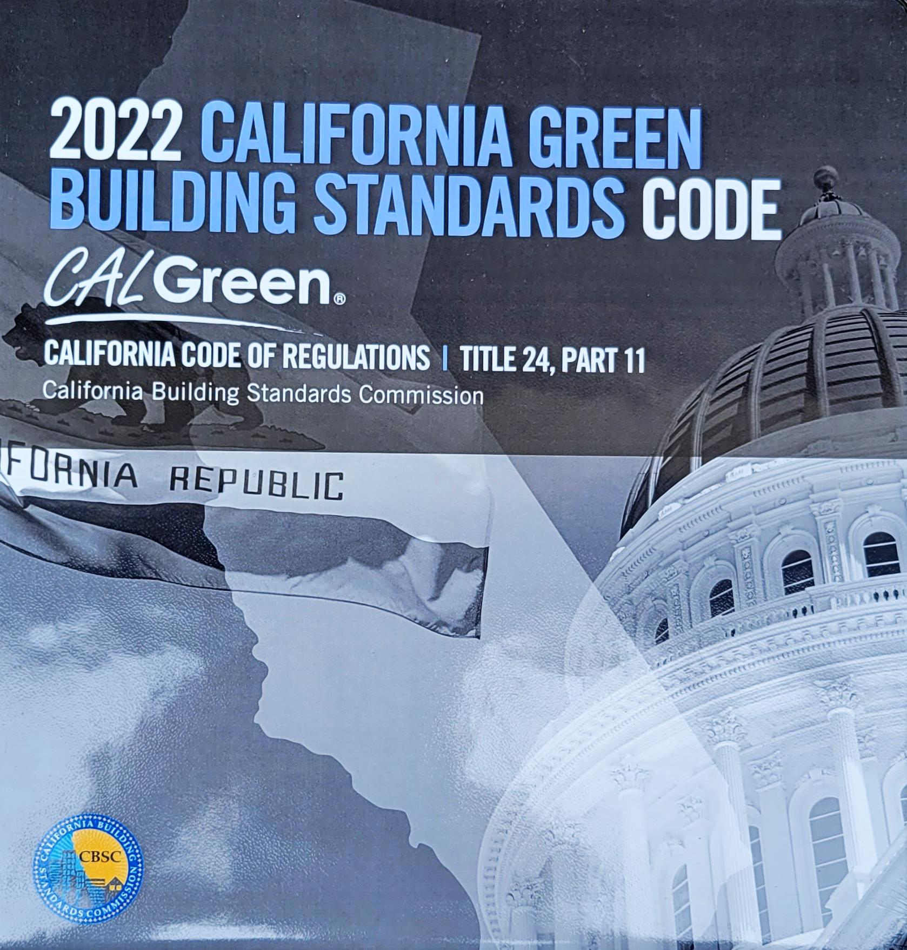
2022 CALGreen
RESIDENTIAL MANDATORY MEASURES CHECKLIST
(Effective January 1, 2023)

SECTION | MEASURES | REQUIREMENTS |  | Measures provided on plan sheet¹:
ADMINISTRATION
101.3.1 | Application | Applies to all newly constructed residential buildings: low rise, high rise, and hotels/motels.
GREEN BUILDING (Scope)
301.1.1 | Additions and Alterations | - Applies to additions or alterations of existing residential buildings where the addition or alteration increases the building’s conditioned area, volume, or size.  - Requirements only apply within the specific area of the addition or alteration.
PLANNING AND DESIGN (Site Development)
4.106.2 | Storm Water Drainage and Retention During  Construction | A plan is developed and implemented to manage storm water drainage during construction.
4.106.3 | Grading and Paving | Construction plans shall indicate how site grading or drainage system will manage all surface water flows to keep water from entering buildings.
4.106.4.1 | Electric Vehicle (EV) Charging for New Construction | Provide capability for electric vehicle charging for one- and two-family dwellings; townhouses with attached private garages in accordance with Sections 4.106.4.1.
4.106.4.2 |  | Provide capability for electric vehicle charging for multifamily dwellings and hotels/motel in accordance with Sections 4.106.4.2.1 or 4.106.4.2.2, as applicable.
4.106.4.3 |  | Provide capability for electric vehicle charging for existing parking lots or new parking lots for existing residential buildings in accordance with Sections 4.106.4.3, as applicable.
ENERGY EFFICIENCY
4.201.1 | General | Building meets or exceeds the requirements of the 2022 California Building Energy Efficiency Standards.
WATER EFFICIENCY AND CONSERVATION (Indoor Water Use)
4.303.1 | Water Conserving Plumbing Fixtures and Fittings |  | Plumbing fixtures (water closets and urinals) and fittings (showerheads, faucets and pre-rinse spray valves) installed in residential buildings shall comply with requirements of Sections 4.303.1.1 through 4.303.1.4.5:  Plumbing fixtures & fittings Maximum flow rate  Water closets 1.28 gallons/flush  Showerheads 1.8 gpm @ 80 psi  Kitchen faucets 1.8 gpm @ 60 psi  Residential lavatory faucets 1.2 gpm @ 60 psi max. and 0.8 gpm @ 20 psi min.  Lavatory faucets in common & public use areas 0.5 gpm @ 60 psi  Metering faucets 0.20 gallons/cycle  Urinals 0.125 gallons/flush for wall-mounted type and 0.5 gallons/flush for floor-mounted type or other type  Pre-rinse spray valves (with an integral automatic shutoff) 1.00 gpm for Product Class 1 (≤ 5.0 ozf) 1.20 gpm for Product Class 2 (> 5.0 ozf and ≤ 8.0 ozf) 1.28 gpm for Product Class 3 (> 8.0 ozf)
4.303.2 | Submeters for multifamily buildings and dwelling units in mixed-use residential/commercial buildings |  | Submeters shall be installed to measure water usage of individual rental dwelling units in accordance with 2022 California Plumbing Code.
4.303.3 | Standards for Plumbing Fixtures and Fittings |  | Plumbing fixtures and fittings required in Section 4.303.1 shall be installed in accordance with the 2022 California Plumbing Code, and shall meet the applicable referenced standards.
WATER EFFICIENCY AND CONSERVATION (Outdoor Water Use)
4.304.1 | Outdoor potable water use in landscape areas | Residential developments shall comply with a local water efficient landscape ordinance or the current California Department of Water Resources’ Model Water Efficient Landscape Ordinance (MWELO), whichever more stringent.
MATERIAL CONSERVATION & RESOURCE EFFICIENCY (Enhanced Durability & Reduced Maintenance)
4.406.1 | Rodent proofing | Annular spaces around pipes, electric cables, conduits, or other openings in plates at exterior walls shall be protected against the passage of rodents by closing such openings with cement mortar, concrete masonry or a similar method acceptable to the enforcing agency.
MATERIAL CONSERVATION & RESOURCE EFFICIENCY (Construction Waste Reduction, Disposal & Recycling)
4.408.1 | Construction Waste Management | Recycle and/or salvage for reuse a minimum of 65% of the nonhazardous construction and demolition waste in accordance with one of the following:  - Comply with a more stringent local construction and demolition waste management ordinance; or  - A construction waste management plan, per Section 4.408.2; or  - A waste management company, per Section4.408.3; or  - The waste stream reduction alternative, per Section 4.408.4.
MATERIAL CONSERVATION & RESOURCE EFFICIENCY (Building Maintenance & Operation)
4.410.1 | Operation and Maintenance Manual | An operation and maintenance manual shall be provided to the building occupant or owner.
4.410.2 | Recycling by Occupants | Where 5 or more multifamily dwelling units are constructed on a building site, provide readily accessible areas that serve all buildings on the site and is identified for the depositing, storage and collection of non-hazardous materials for recycling, including (at a minimum) paper, corrugated cardboard, glass, plastics, organic waste, and metals or meet a lawfully enacted local recycling ordinance, if more restrictive. See exception for rural jurisdictions.
ENVIRONMENTAL QUALITY (Fireplaces)
4.503.1 | General | Any installed gas fireplace shall be a direct-vent sealed-combustion type. Any installed woodstove or pellet stove shall comply with U.S. EPA New Source Performance Standards (NSPS) emission limits as applicable, and shall have a permanent label indicating they are certified to meet the emission limits. Woodstoves, pellet stoves and fireplaces shall also comply with all applicable local ordinances.
ENVIRONMENTAL QUALITY (Pollutant Control)
4.504.1 | Covering of Duct Openings & Protection of Mech. Equipment During Construction | Duct openings and other related air distribution component openings shall be covered during construction.
4.504.2.1 | Adhesives, Sealants and Caulks | Adhesives, sealants and caulks shall be compliant with VOC and other toxic compound limits.
4.504.2.2 | Paints and Coatings | Paints, stains and other coatings shall be compliant with VOC limits.
4.504.2.3 | Aerosol Paints and Coatings | Aerosol paints and coatings shall be compliant with product weighted MIR limits for ROC and other toxic compounds.
4.504.2.4 | Verification | Documentation shall be provided to verify that compliant VOC limit finish materials have been used.
4.504.3 | Carpet Systems | Carpet and carpet systems shall be compliant with VOC limits.
4.504.4 | Resilient Flooring Systems | 80 percent of floor area receiving resilient flooring shall comply with specified VOC criteria.
4.504.5 | Composite Wood Products | Particleboard, medium density fiberboard (MDF) and hardwood plywood used in the interior finish systems shall comply with low formaldehyde emission standards.
ENVIRONMENTAL QUALITY (Interior Moisture Control)
4.505.2 | Concrete Slab Foundations | Vapor retarder and capillary break is installed at slab-on-grade foundations.
4.505.3 | Moisture Content of Building Materials | Moisture content of building materials used in wall and floor framing is checked before enclosure.
ENVIRONMENTAL QUALITY (Indoor Air Quality & Exhaust)
4.506.1 | Bathroom Exhaust Fans | Each bathroom shall be provided with the following:  - ENERGY STAR fans ducted to terminate outside the building.  - Fans must be controlled by a humidity control (separate or built-in); OR functioning as a component of a whole-house ventilation system.  - Humidity controls shall with manual or automatic means of adjustment, capable of adjustment between a relative humidity range of ≤ 50% to a maximum of 80%.  Note: For the purposes of this section a bathroom is a room which contains a bathtub, shower, or tub/shower combination. Fans are required in each bathroom.
ENVIRONMENTAL QUALITY (Environmental Comfort)
4.507.2 | Heating and Air Conditioning System Design | Duct systems are sized, designed, and equipment is selected using the following methods:  - Establish heat loss and heat gain values according to ANSI/ACCA 2 Manual J-2016 (Residential Load Calculation), or equivalent.  - Size duct systems according to ANSI/ACCA 1 Manual D- 2016 (Residential Duct Systems), or equivalent.  - Select heating and cooling equipment according to ANSI/ACCA 3 Manual S-2014 (Residential Equipment Selection) or equivalent.
INSTALLER & SPECIAL INSPECTOR QUALIFICATIONS (Qualifications, Verifications)
702.1 | Installer Training | HVAC system installers are trained and certified in the proper installation of HVAC systems.
702.2 | Special Inspection | Special inspectors must be qualified and able to demonstrate competence to the enforcing agency in the discipline in which they are inspecting.
703.1 | Documentation | Verification of compliance with this code may include construction documents, plans, specifications, builder or installer certification, inspection reports, or other methods acceptable to the enforcing agency which show substantial conformance.

Footnotes:
¹ Indicate N/A if not applicable.

Note: This check list is intended only as an aid to the user and may not contain complete code language. Refer to 2022 CALGreen Chapter 4 for complete code language.

