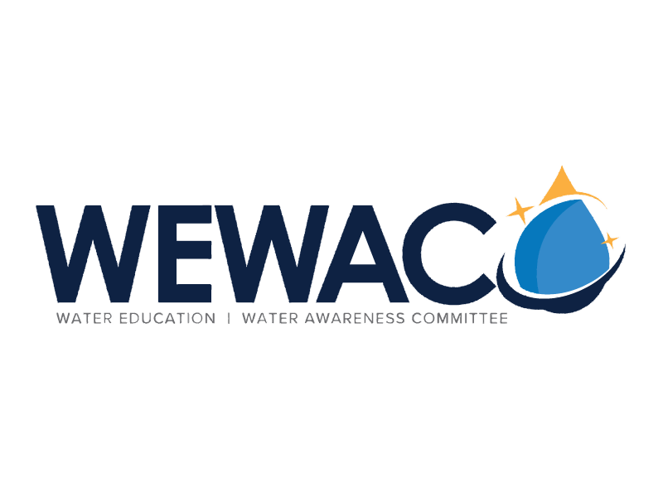

**REGISTRATION FORM:WATER MEDIA CAMPAIGN**

School:

School Address:

School Telephone Number:

School District:

City:

Fax:

Digital Art Title:

Participants’ Names: (Please include all participants)

Brief Summary of Production:

Broadcast Media Title:

Participants’ Names: (Please include all participants)

Brief Summary of Production:

Length of Broadcast Media: Length of **Copyright/Non-Original** Material:

***The school Principal and supervising Student Advisor acknowledge and hereby agree to abide by all “Eligibility” rules as listed on the entry application explanation sheet.***

Principal’s Signature: Date:

Principal’s Name (Please Print):

Advisor’s Signature:

Advisor’s Name (Please Print):

 Advisor’s Contact Information: Phone: Email:

I hereby assign all rights of the broadcast media and digital art made on the dates of by the media production company, hereafter called Junior High/High School or Group name. In addition, I hereby authorize the reproduction, sale, copyright, exhibition, broadcast and/or distribution of said production without limitation. I hereby certify that I am over twenty-one (21) years of age, and competent to contract in my own name in so far as the above is concerned.

**MEDIA PRODUCTION RELEASE (Advisor’s Signature)**

Entrants whose broadcast media or digital art are chosen for inclusion in a program must sign a release attesting to the fact that they are the rightful owners of the submitted material. All persons appearing in the broadcast media or digital art must sign consent forms and/or releases before their material can be broadcast. Minors are asked to have a parent or guardian sign the consent/release form.

Parent / Guardian

Please Print Name Street Address

Signature City, State, Zip Code

Date Telephone Number

**Water Media Campaign 2019!**

**CHILD’S RELEASE (Parent’s Signature)**

I/We (parent or guardian names) hereby assign all rights to the broadcast media or digital art material made of me/or my child (Child’s name) on the dates of by the production company, hereafter called Junior High/High School or Group name*.* In addition, I hereby authorize the reproduction, sale, copyright, exhibition, broadcast and/or distribution of said production without limitations. I hereby certify that I am the legal parent/or guardian of the above-named child.

Street Address

City, State, Zip Code

Telephone Number

Please Print Name

Signature

Date