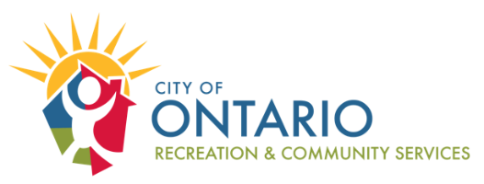

LIABILITY WAIVER, HOLD HARMLESS, AND ASSUMPTION OF RISK:
I give my permission for the above-listed person to participate in the above-listed activity (“Activity”) being sponsored by the City of Ontario (“City”). I certify that the participant(s) is/are in good health and do not have any communicable diseases or illnesses, including COVID-19. I/We understand that participation in the Activity exposes me/us to the risk of personal injury, death, communicable diseases, illnesses, viruses, and/or property damage. I/We acknowledge we voluntarily are participating in this Activity and assume such risk.

The novel coronavirus, COVID-19 is extremely contagious and is believed to spread mainly from person-to-person contact. As a result, many governments and health agencies have recommended at various times social distancing and prohibited the congregation of groups of people. Although the City may follow applicable COVID-19 safety protocols, I understand that there is no guarantee that I will not become infected with COVID-19 by participating in the Activity and that my participation in the Activity may increase my risk of contracting COVID-19. By signing below, I acknowledge the contagious nature of COVID-19 and other communicable diseases and voluntarily assume the risk that I may be exposed to, or infected by COVID-19 by participating in the Activity, and that such exposure or infection may result in personal injury, illness, permanent disability, and death.

I, for myself, my heirs, administrators, executors, distributees, guardians, legal representatives, and assigns hereby waive, release, and discharge any and all claims or right to claims, and agree not to sue for damages for any legal or equitable remedies, including but not limited to bodily injury or damage or loss of personal property which may have, or which may hereafter occur to me as a result of my/his/her/their participation in said Activity. This release is intended to discharge in advance the promoters, sponsors, employees, officials, and any involved municipalities or other public entities and each of their officials, officers, employees, volunteers, and agents (the “Releasees”) from and against any and all legal or equitable liabilities which may arise out of the active or passive negligence or carelessness on the part of the Releasees. I/We understand that this document is not intended to release any party from any act or omission of “gross negligence,” as that term is used in applicable case law and/or statutory provision.

This release includes any unknown claims related to my/his/her/their participation in said Activity and I/We hereby expressly waive any and all rights that I/We have under California Civil Code Section 1542. Section 1542 of the California Civil Code provides:

“A general release does not extend to claims that the creditor or releasing party does not know or suspect to exist in his or her favor at the time of executing the release and that, if known by him or her, would have materially affected his or her settlement with the debtor or released party.”

I/We, for myself, my administrators, executors, distributees, guardians, legal representatives, heirs, and assigns, hereby agree to INDEMNIFY, DEFEND, AND HOLD HARMLESS the Releasees from any and all claims, demands, actions or suits, in law or in equity, damages, injuries, or losses, including attorneys’ fees, arising out of or in connection with my/his/her/their participation in said Activity.

Additionally, the above registered participant(s) give permission to the City to be photographed or videotaped, and to use such photos or videos in the promotion of City sponsored events.

I HAVE CAREFULLY READ THIS WAIVER, HOLD HARMLESS, AND ASSUMPTION OF RISK AND FULLY UNDERSTAND ITS CONTENTS. I AM AWARE THAT IT IS A FULL RELEASE OF ALL LIABILITY AND SIGN IT OF MY OWN FREE WILL.
Participant Name
Parent/Guardian Name (for participants under the age of 18)
Signature |  |  |  |  | Date

